

SCSJ3323: Software Design and Architecture

**Software Design Document**

UTM Alumni Integrated System

Version 3.0

Printing Date: 25/12/2019

**Section 03**

**Dr. Shahliza Abd Halim**

Software Engineering, Faculty of Computing

Prepared by: Sons of Anarchy

**Revision Page**

**a.** **Overview**

This version of SDD included the Introduction which describes the purpose, scope and overview of the project

**b.** **Target Audience**

This document addresses the design of the UTM ALIS system. The intended audience for this document is the designers and the clients of the project including ​UTM Alumni Students, CICT UTM, UTM Alumni Department, Alumni Associates, UTM Board of Management, Faculties or Schools, Industrial Organizations.

**c.** **Project Team Members**

Team Member - Assigned module

Nazmus Sakib - Manage Membership Module

Muhammad Haziq - Report and Statistics Module

Dip Jyoti Ghosh - Reservation Facility Module

Likneshkanth Rao - Industrial Network Linkage Module

Muhammad Jasim - Activity Management Module

**d.** **Version Control History**

|  |  |  |  |
| --- | --- | --- | --- |
| **Version** | **Primary Author(s)** | **Description of Version** | **Date Completed** |
| 1.0 | Nazmus Sakib  Dip Jyoti Ghosh  Muhammad Haziq  Likneshkanth Rao  Muhammad Jasim | Detailed Design | 20/11/2019 |
| 2.0 | Nazmus Sakib  Dip Jyoti Ghosh  Muhammad Haziq  Likneshkanth Rao  Muhammad Jasim | Detailed design implement design pattern at Module 7 with adding adapter and prototype. | 16/12/2019 |
| 3.0 | Nazmus Sakib  Dip Jyoti Ghosh  Muhammad Haziq  Likneshkanth Rao  Muhammad Jasim | Construction Design at Module 8 | 22/12/2019 |

**Table Contents**

1. Introduction 6

1.1 Purpose 6

1.2 Scope 6

1.3 Definitions, Acronyms and Abbreviation 6

1.4 Reference Materials 7

1.5 System Overview 7

2. System Architectural Design 8

2.1 Architecture Style and Rationale 8

2.2 Architecture Model 9

2.3 Use Case Diagram 10

3. Detailed Description of Components 11

3.1 Complete Package Diagram 11

3.2 Detailed Description 12

3.2.1 Module 1 < Membership Management > 12

3.2.1.1 P001: Package < Membership Management >

3.2.1.2 Class Diagram

3.2.1.3 SD01: Sequence Diagrams

3.2.2 Module 2 < Activity Management > 18

3.2.2.1 P004: Package < Activity Management >

3.2.2.2 Class Diagram

3.2.2.3 Sequence Diagrams

3.2.3 Module 3 < Reservation Facility > 24

3.2.3.1 P006: Package < Reservation Facility >

3.2.3.2 Class Diagram

3.2.3.3 Sequence Diagrams

3.2.4 Module < Industrial Network Linkage > 28

3.2.4.1 P007: Package < Industrial Network Linkage >

3.2.4.2 Class Diagram

3.2.4.3 Sequence Diagrams

3.2.5 Module < Report and Statistics > 32

3.2.5.1 P008: Package < Report and Statistics >

3.2.5.2 Class Diagram

3.2.5.3 Sequence Diagrams

4. Data Design 37

4.1 Data Description 37

4.2 Data Dictionary 38

4.2.1 Entity: Alumni 38

4.2.2 Entity: Admin 38

4.2.3 Entity: Registration 39

4.2.4 Entity: Reservation 40

4.2.5 Entity: Job 41

4.2.6 Entity: Employer 41

4.2.7 Entity: Donation 42

4.2.8 Entity: Organization 42

5. User Interface Design 43

5.1 Overview of User Interface 43

5.1.1 Membership Management 43

5.1.2 Activity Management 43

5.1.3 Reservation Facility 44

5.1.4 Industrial Network Linkage 44

5.1.5 Report and Statistics 44

5.2 Screen Images 45

5.2.1 Membership Management 45

5.2.2 Activity Management 48

5.2.3 Reservation Facility 49

5.2.4 Industrial Network Linkage 52

5.2.5 Report and Statistics 55

6. Requirements Matrix 57

7.0 Design Pattern 58

8.0 Construction Design 59

8.1 Flow based 59

8.2 State Based 59

8.3 Table Based 60

**1.** **Introduction**

**1.1** **Purpose**

This SDD describes in detail about the proposed UTM ALIS. This document describes the architectural pattern and the detailed design. This document is meant to convey an in-depth understanding of the entire proposed system and also its flow.

The audience (stakeholders) for the user requirement document are:

● UTM Alumni

● CICT UTM

● UTM Alumni Department

● UTM Board of Management

● Faculties or Schools

● Industrial Organizations

**1.2** **Scope**

This system is used by alumni or students about to graduate and may not be used by any other students. This system will interact with the following databases: UTMSPACE Student Database, UTM Franchise Student Database, and UTM Foundation Student Database. This software product is expected to achieve the following features: Distributing the job opportunities among alumni, manage facilities reservations, manage donations, allow alumni membership, view report and statistics.

* 1. **Definitions, Acronyms and Abbreviation**

Definitions of all terms, acronyms and abbreviations used are to be defined here.

* Alumni - Men and women who have completed their studies at a college or university
* UTM - Universiti Teknologi Malaysia
* ALIS - Alumni Integrated System

**1.4** **References**

* UTM ALIS old website

**1.5** **Overview**

This documentation will highlight on 5 main aspects. Starting from the system architectural style that will be shown and elaborated. Moving on to the description of the component where we will divide the system into subsystems and provide the class diagram and sequence diagram for each sub-system. Later, the documentation will discuss the data design where the data description and data dictionary will be shown. Then, the user interface design where we will show how the user interface will look like. Requirements Matrix will be the last parts to show the cross-reference and to test the cases that we have.

**2.** **System Architectural Design**

**2.1** **Architecture Style and Rationale**

The chosen architecture is Model-view-controller architecture (MVC). The reasons are:

1. Faster development process:

MVC supports rapid and parallel development. If an MVC model is used to develop any particular web application, then it is possible that one programmer can work on the view while another can work on the controller to create business logic of the web application. Hence this way, the application developed using MVC model can be completed three times faster than applications that are developed using other development pattern.

2. Ability to provide multiple views:

In the MVC Model, you can create multiple views for a model. Today, there is an increasing demand for new ways to access your application and for that MVC development is certainly a great solution. Moreover, in this method, Code duplication is very limited because it separates data and business logic from the display.

3. Support for asynchronous technique:

The MVC architecture can also integrate with the JavaScript Framework. This means that MVC applications can be made to work even with PDF files, site-specific browsers, and also with desktop widgets. MVC also supports asynchronous technique, which helps developers to develop an application that loads very fast.

4. Modification does not affect the entire model:

For any web application, user interface tends to change more frequently than even the business rules of the company. It is obvious that you make frequent changes in your web application like changing colours, fonts, screen layouts, and adding new device support for mobile phones or tablets. Moreover, adding new types of views are very easy in MVC pattern because the Model part does not depend on the views part. Therefore, any changes in the Model will not affect the entire architecture.

5. MVC model returns the data without formatting:

MVC pattern returns data without applying any formatting. Hence, the same components can be used and called for use with any interface. For example, any kind of data can be formatted with HTML, but it could also be formatted with Macromedia Flash or Dreamweaver.

**2.2** **Architecture Model**

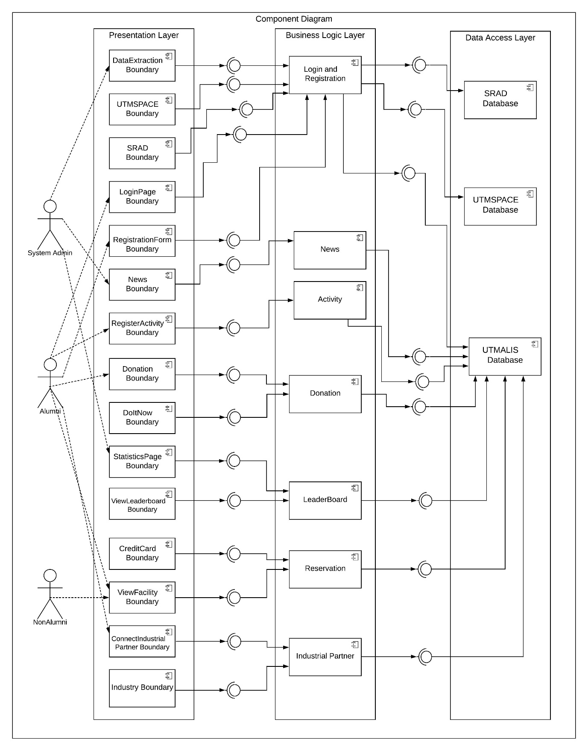

**Figure 2.2: Component Model of UTM ALIS**

**2.3** **Use Case Diagram**

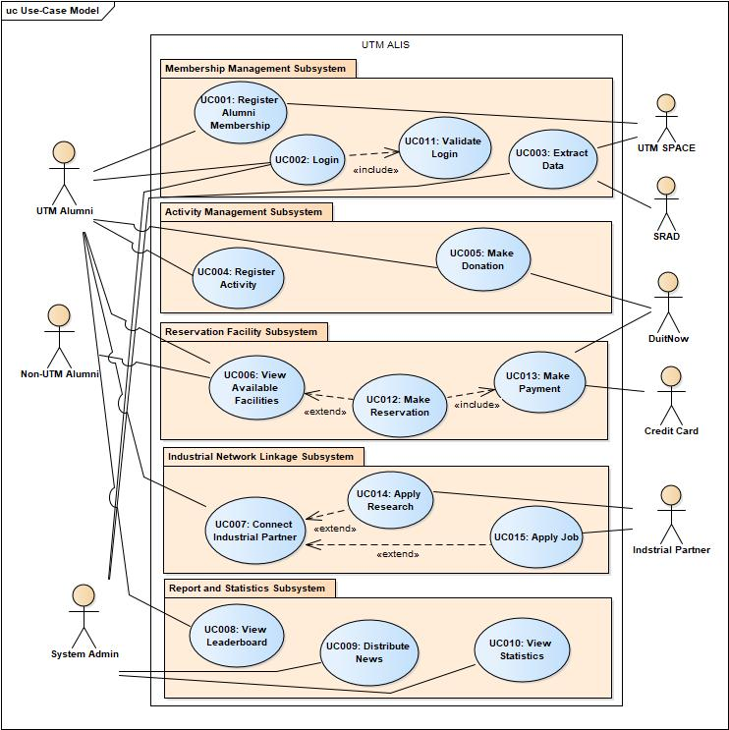

**Figure 2.3: Use Case Diagram of UTM ALIS**

**3.** **Detailed Description of Components**

**3.1** **Complete Package Diagram**

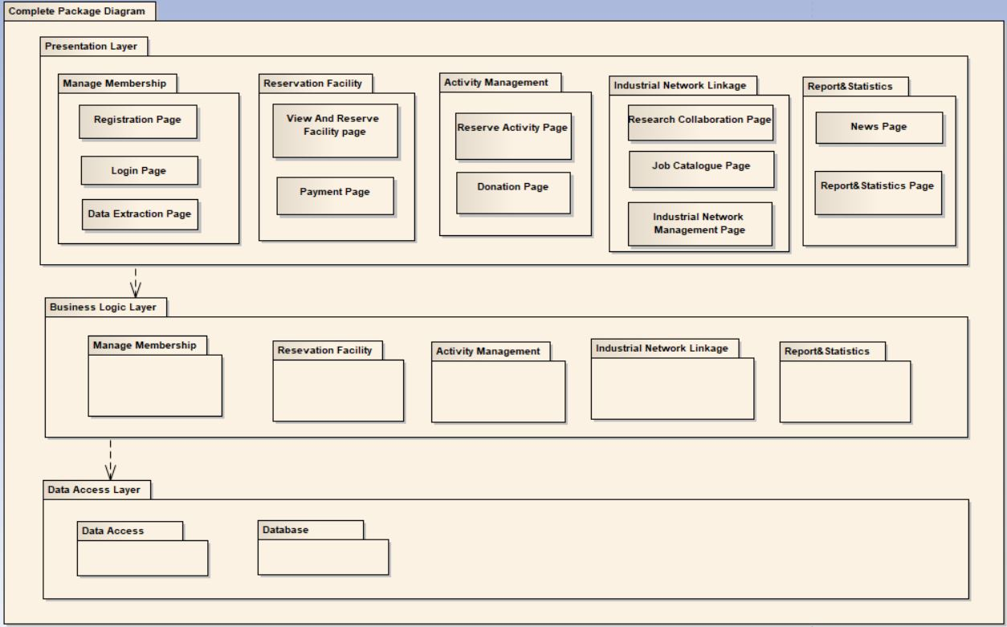

**Figure 3.1: Package Diagram of UTM ALIS**

**3.2** **Detailed Description**

**3.2.1** **Module Membership Management**

**3.2.1.1.1** **P001: Package <Registration Submodule>**

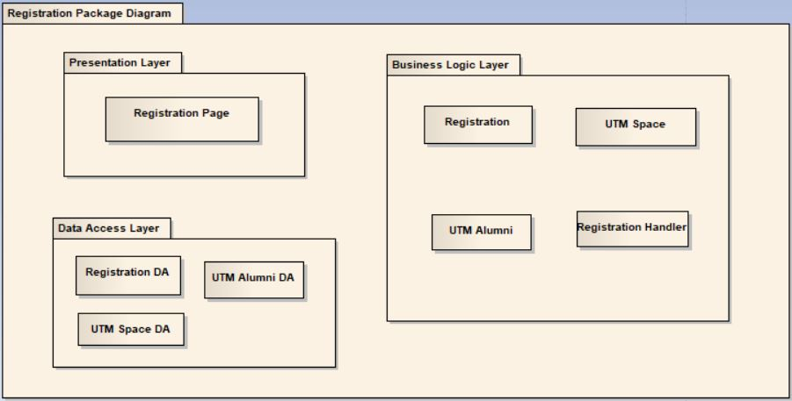

**Fig 3.2.1.1.1: Package diagram for Registration**

**3.2.1.1.2** **Class Diagram**

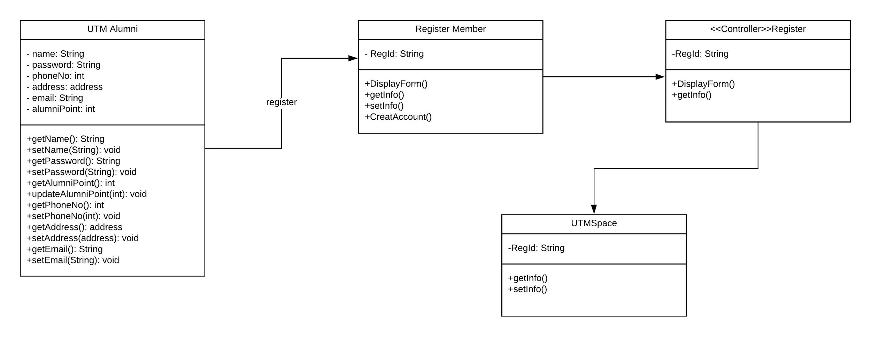

**Fig 3.2.1.1.2: Class diagram for Registration**

**3.2.1.1.3** **Sequence Diagrams SD001: Registration**

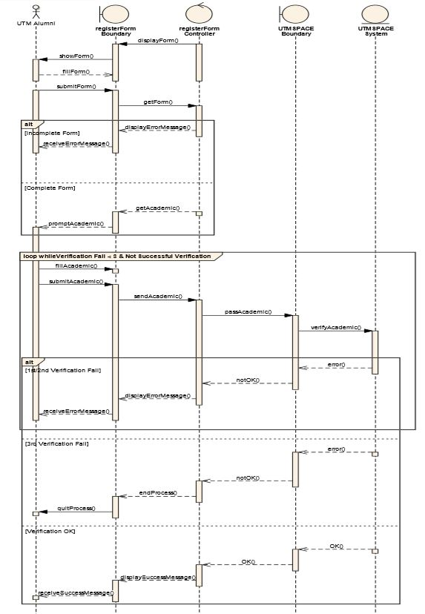

**Figure 3.2.1.1.3: Sequence Diagram of <Registration>**

**3.2.1.2.1** **P002: Package <Login and Validation Submodule>**

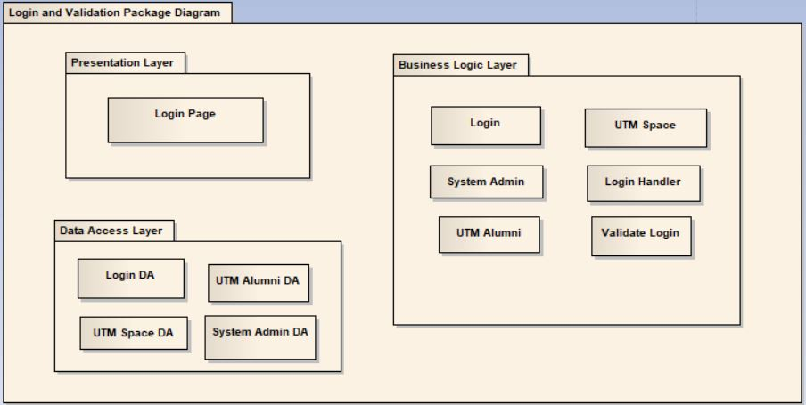

**Figure 3.2.1.2.1: Package Diagram of <Login and Validation>**

**3.2.1.2.2** **Class Diagram**

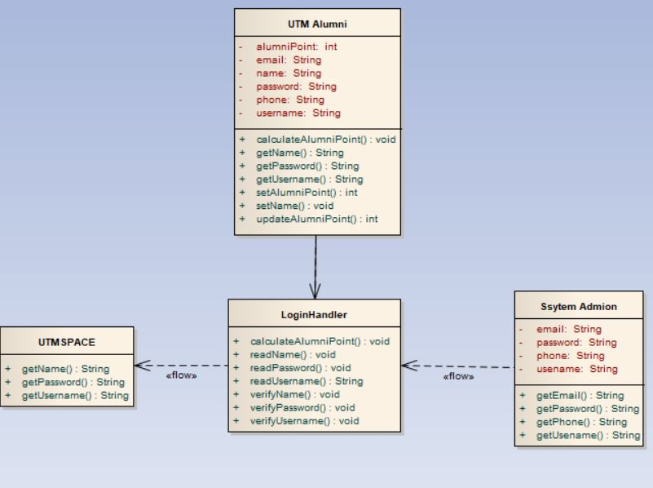

**Figure 3.2.1.2.2: Class Diagram of <Login and Validation>**

**3.2.1.2.3** **Sequence Diagrams SD002: Login and validation**

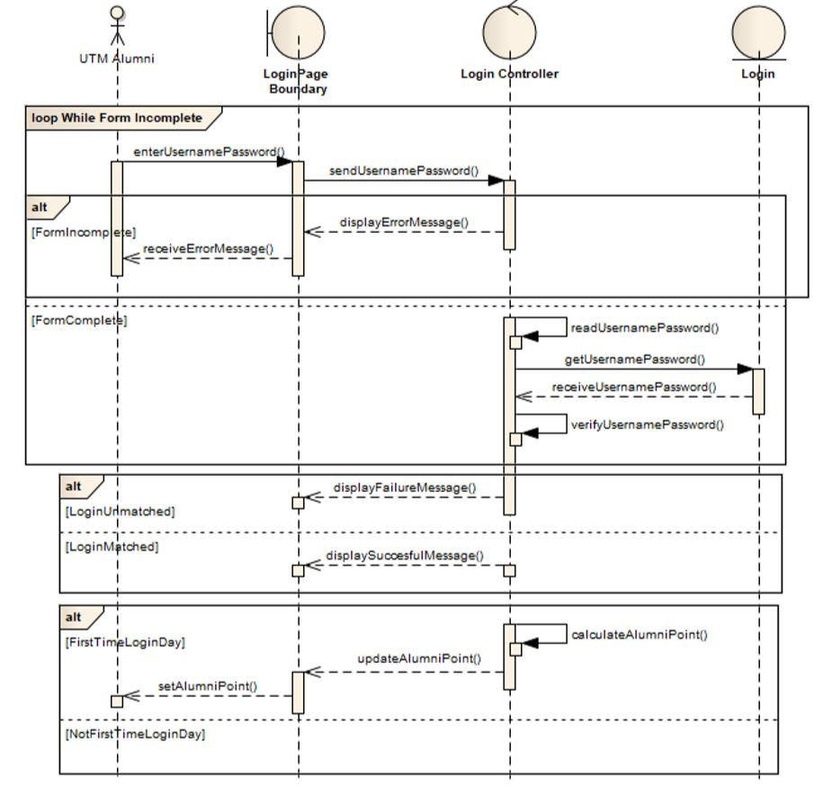

**Figure 3.2.1.2.3: Sequence Diagram of <Login and validation>**

**3.2.1.3.1** **P003: Package <Data Extraction Submodule>**

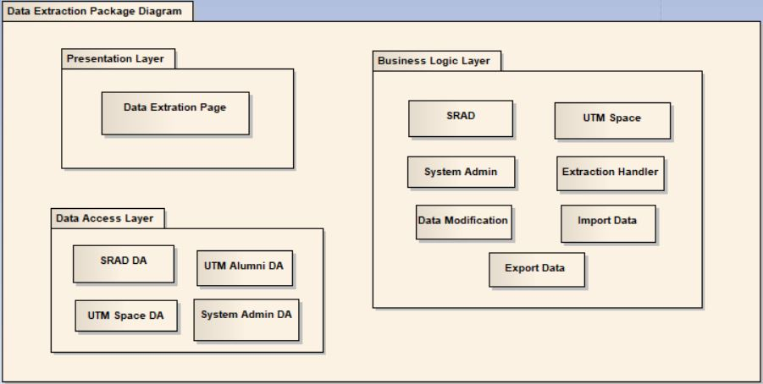

**Figure 3.2.1.3.1: Package Diagram of <Data Extraction>**

**3.2.1.3.2** **Class Diagram**

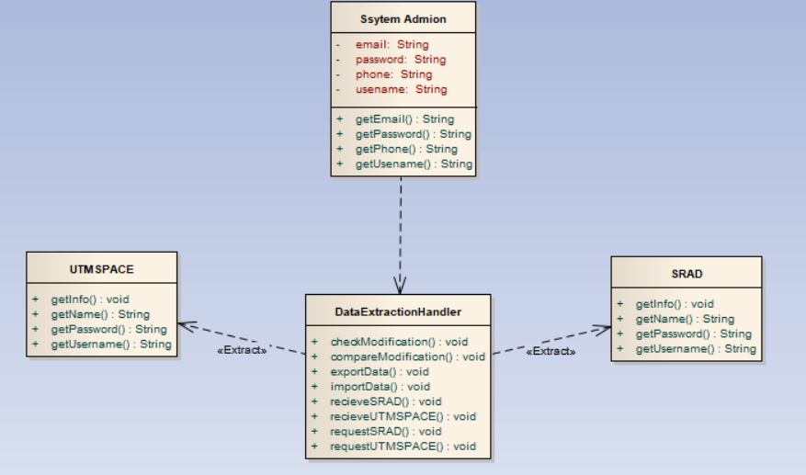

**Figure 3.2.1.3.2: Class diagram for <Data Extraction>**

**3.2.1.3.3** **Sequence Diagrams SD003: Data Extraction**

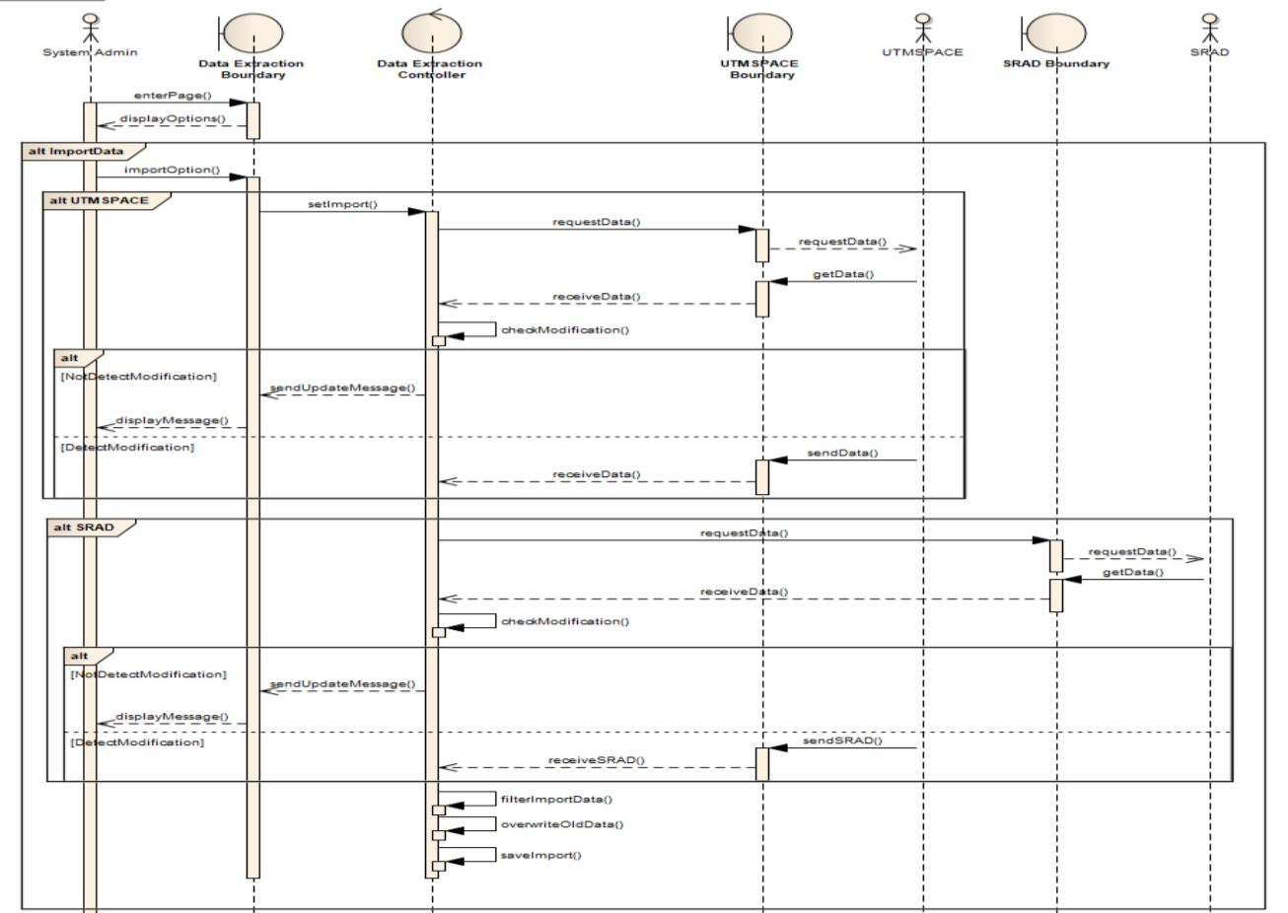

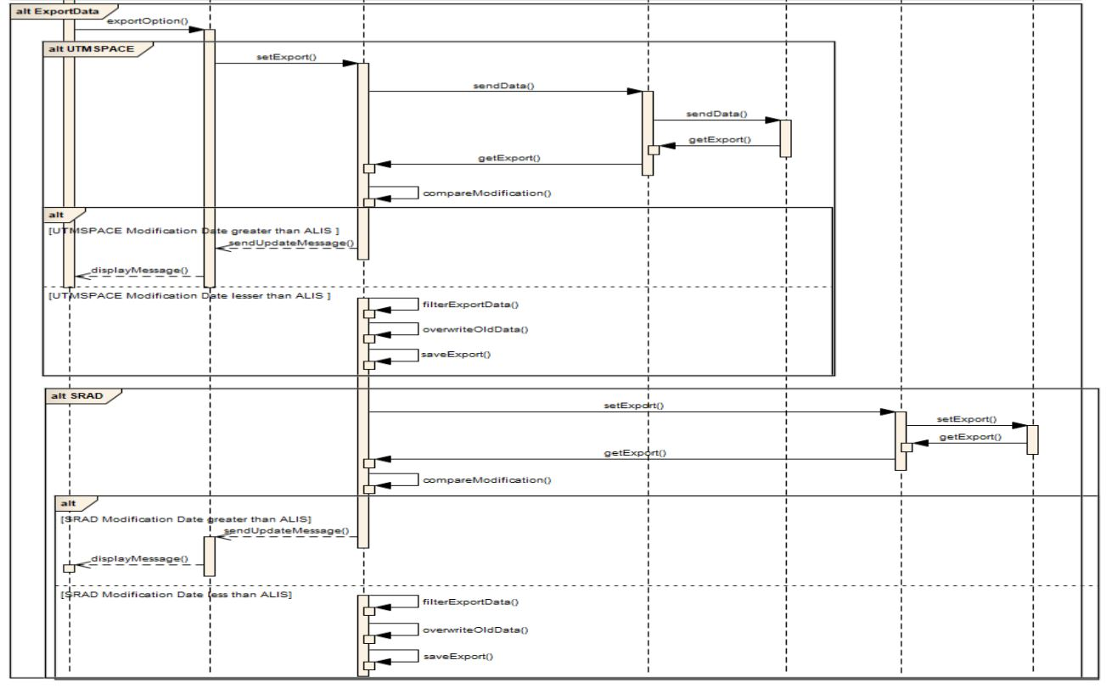

**Figure 3.2.1.3.3: Sequence Diagram of <Data Extraction>**

**3.2.2** **Module Activity Management**

**3.2.2.1.1** **P004: Package Register Activity**

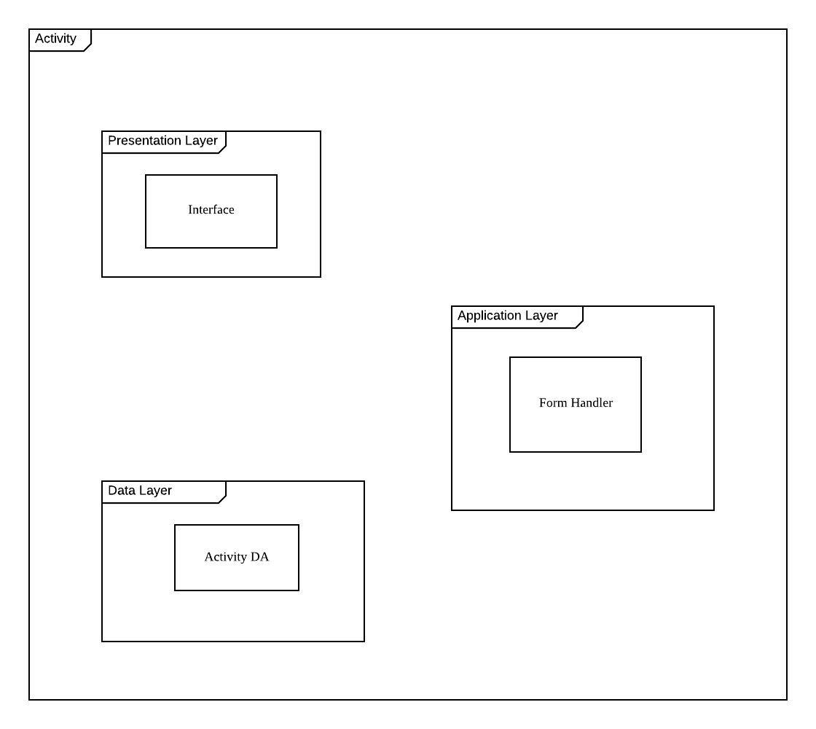

**3.2.2.1.2** **Class Diagram**

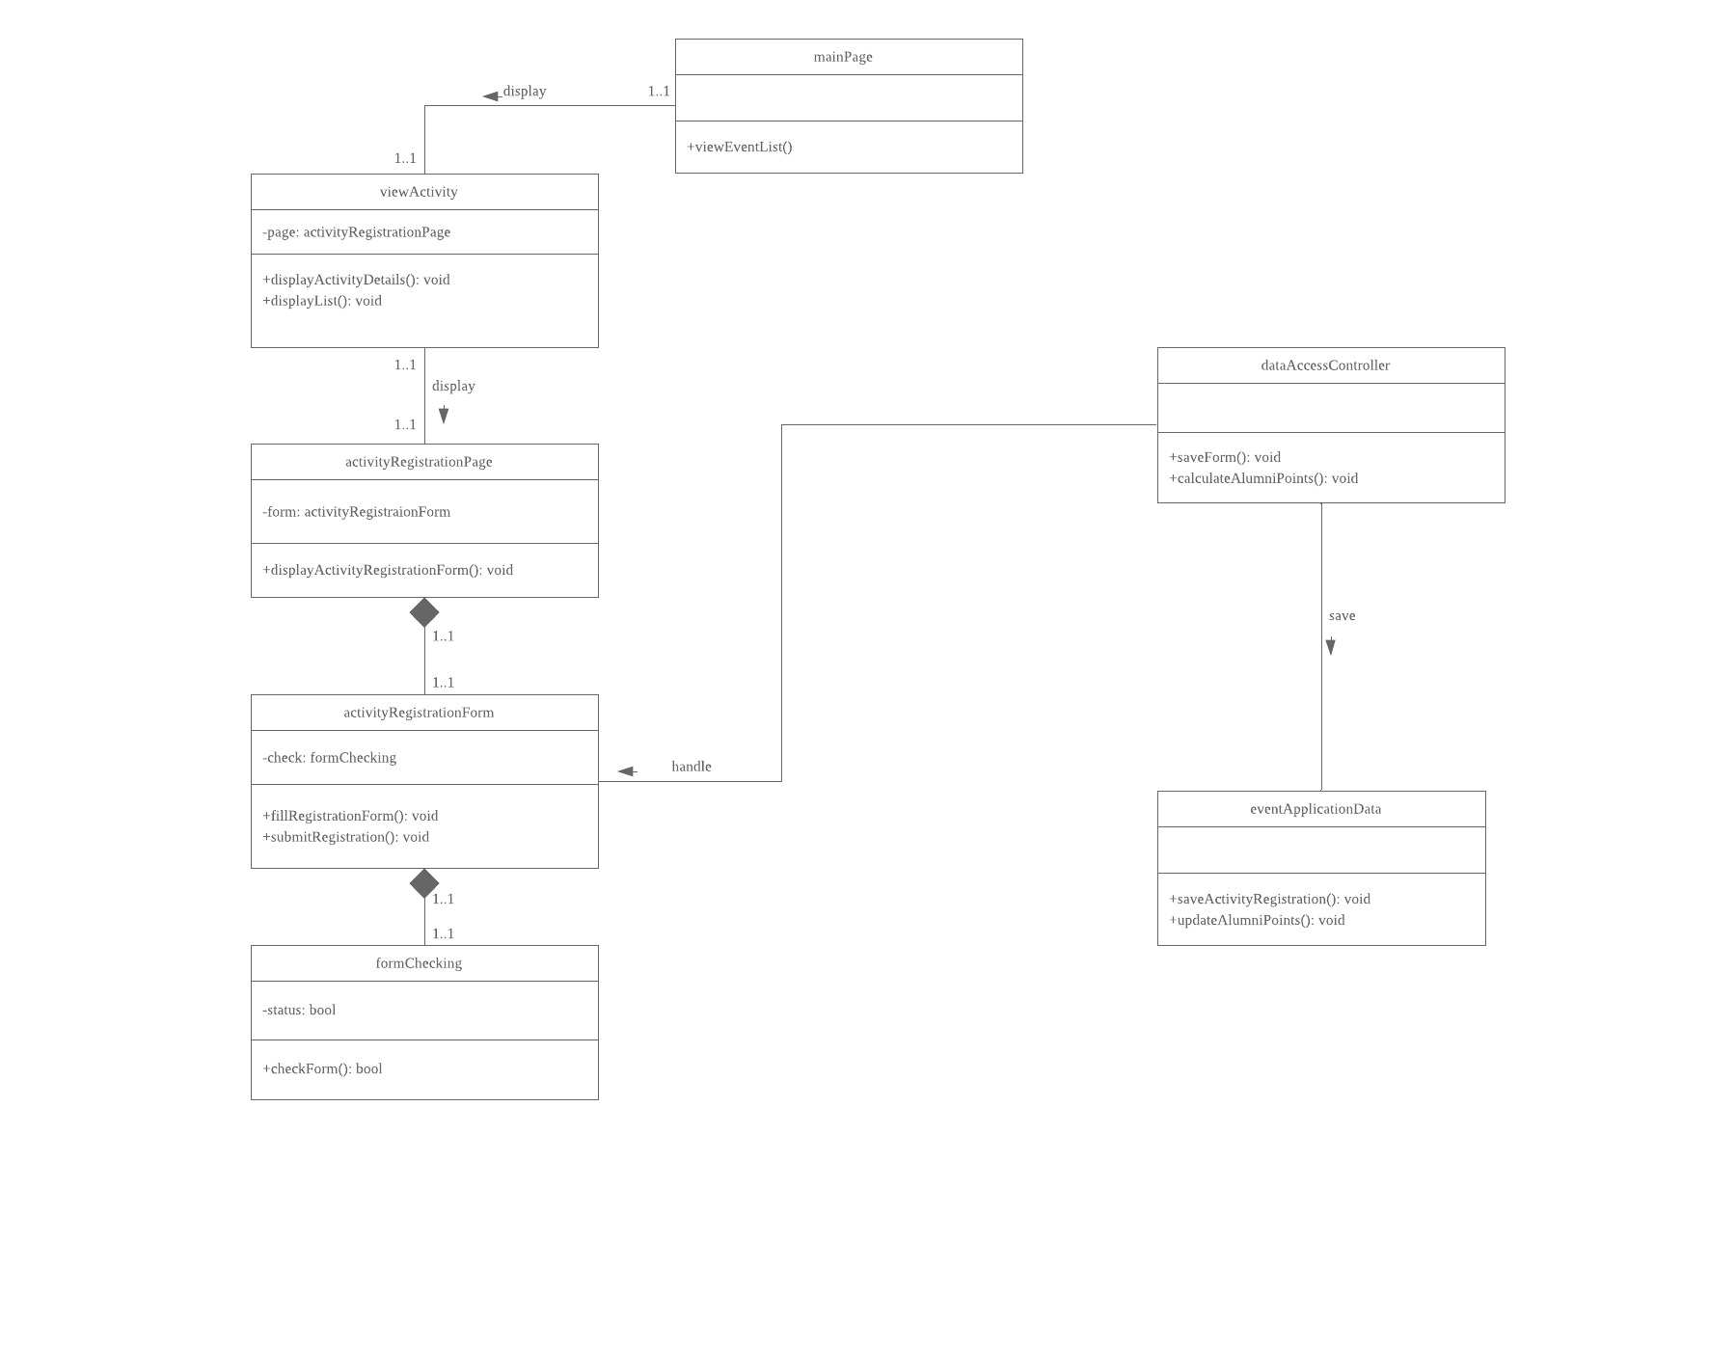

**3.2.2.1.3** **Sequence Diagrams SD004: Register Activity**

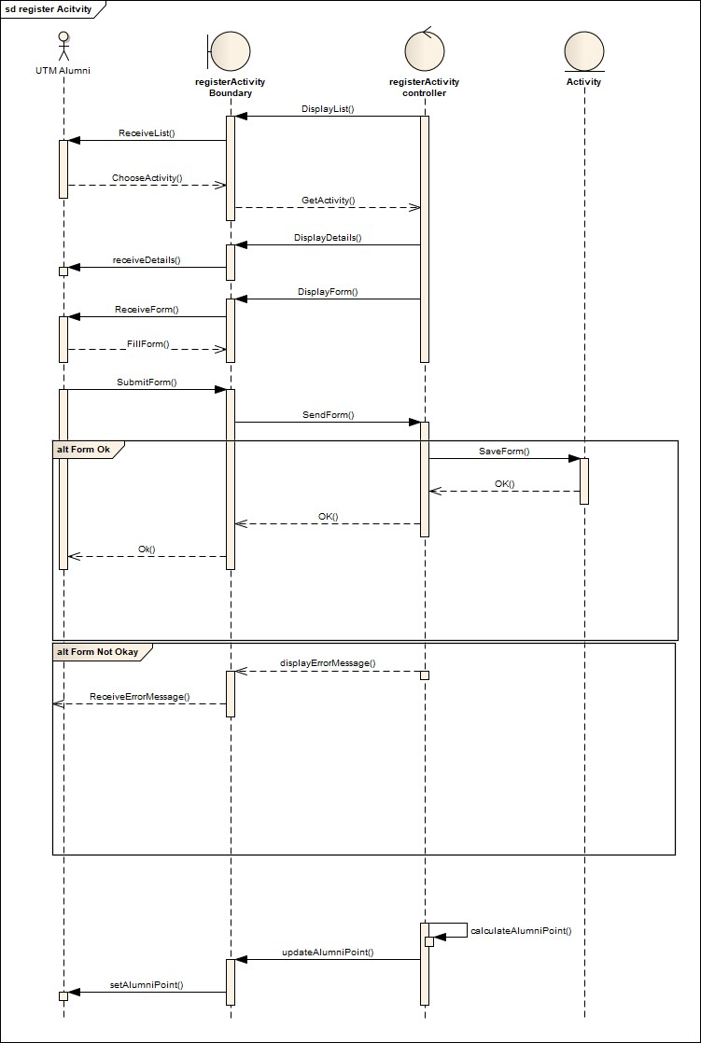

**3.2.2.2.1** **P005: Package Make Donation**

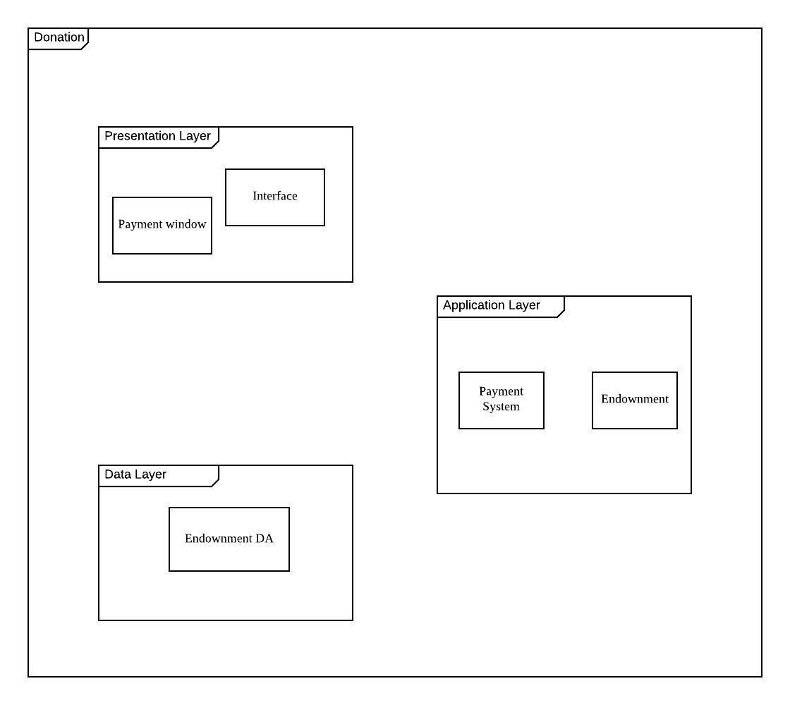

**3.2.2.2.2** **Class Diagram**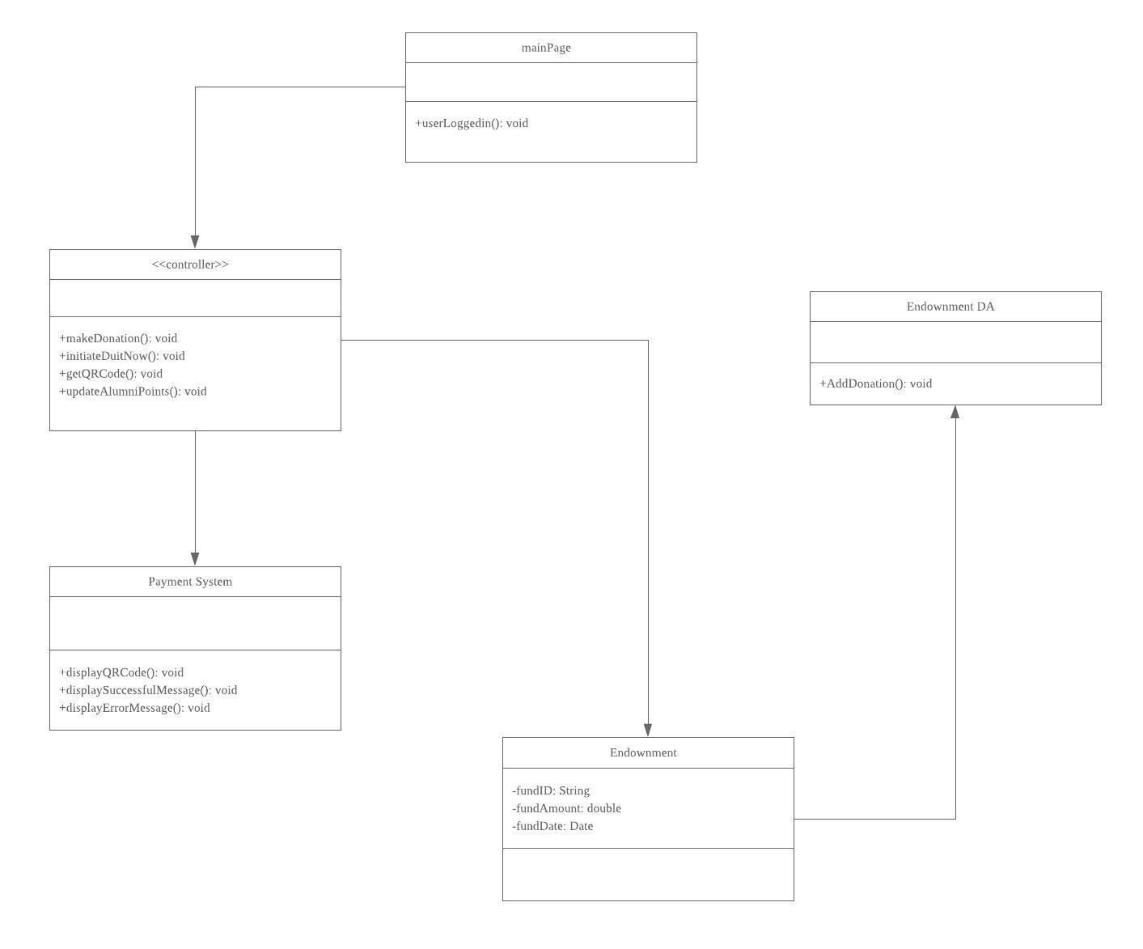

**3.2.2.2.3** **Sequence Diagrams SD005: Make Donation**

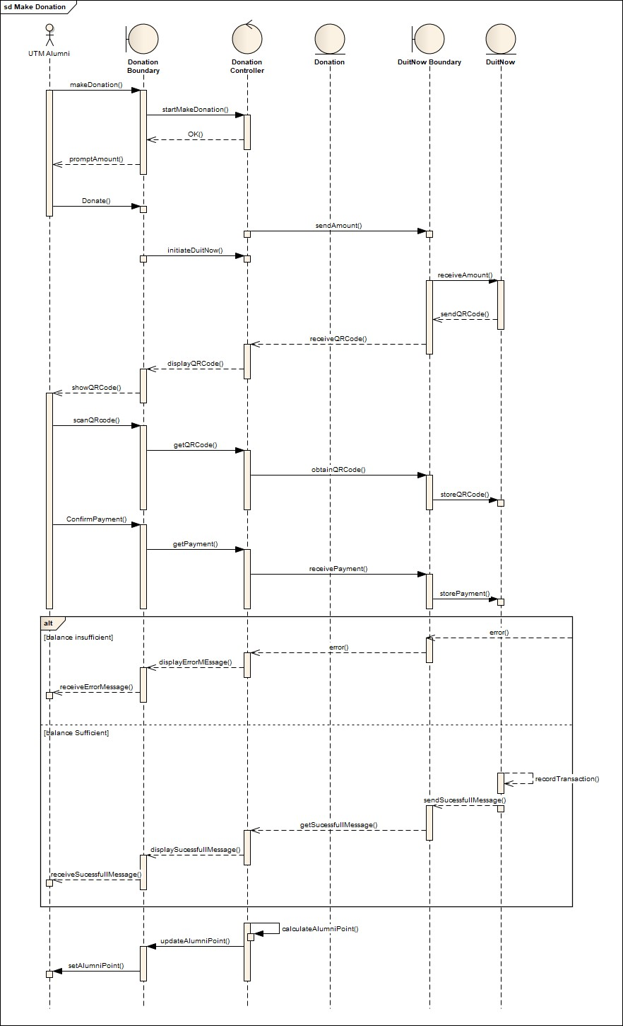

**3.2.3** **Module Reservation Facility**

**3.2.3.1 P006: Package Reservation Module**

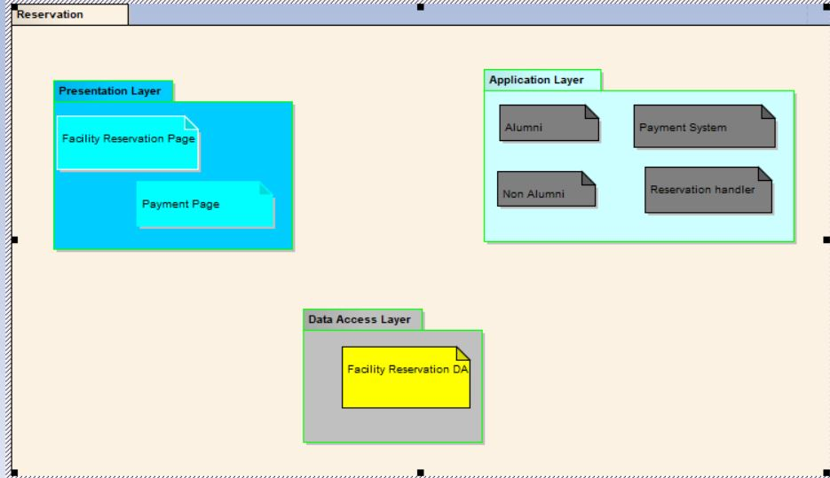

**3.2.3.2 : Class Diagram**

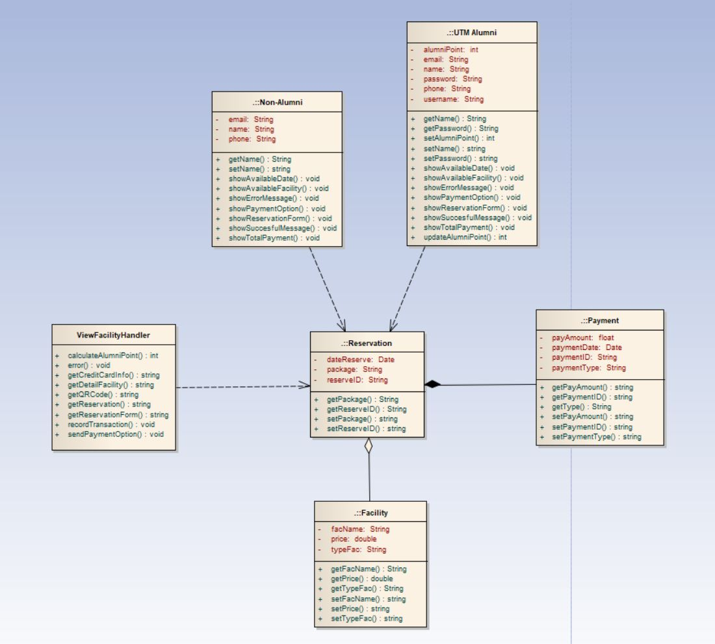

**3.2.3.3 : Sequence Diagram SD006: Reservation Facility**

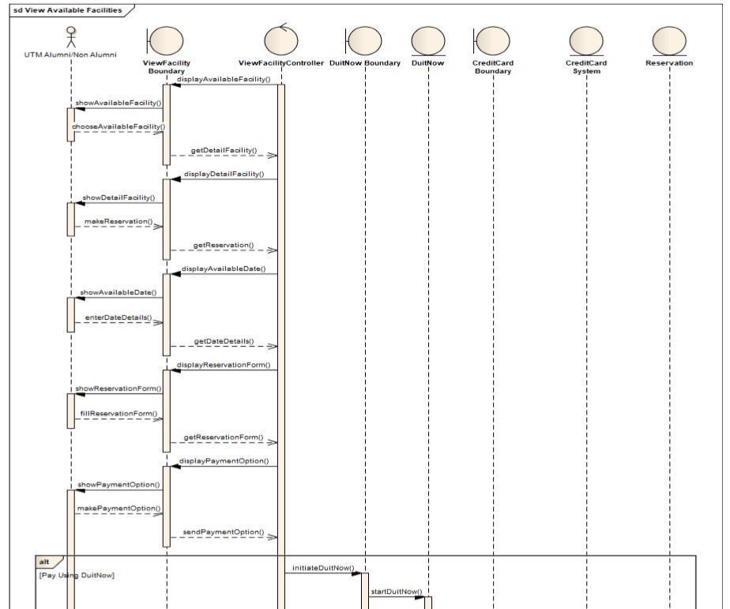

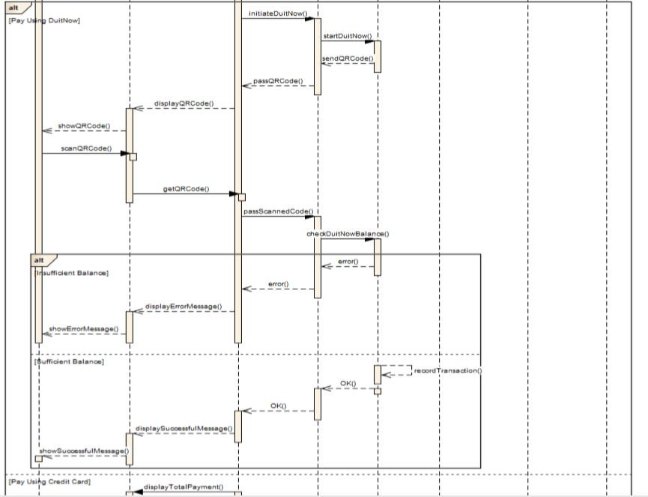

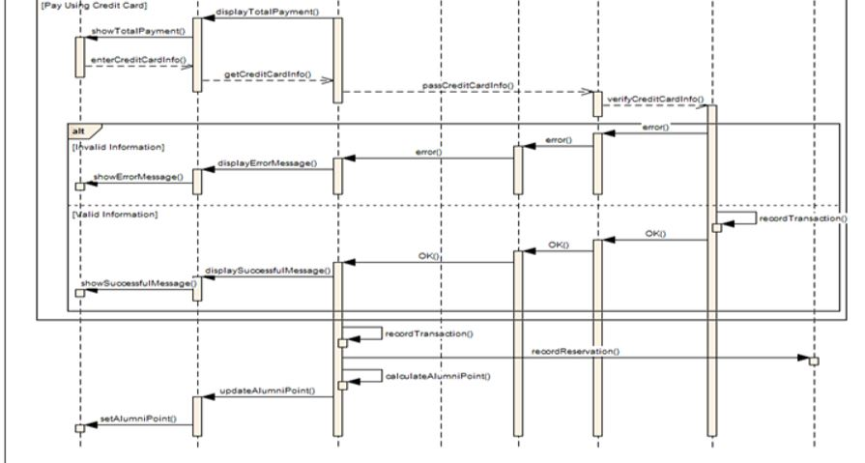

**3.2.4** **Module Industrial Network Linkage**

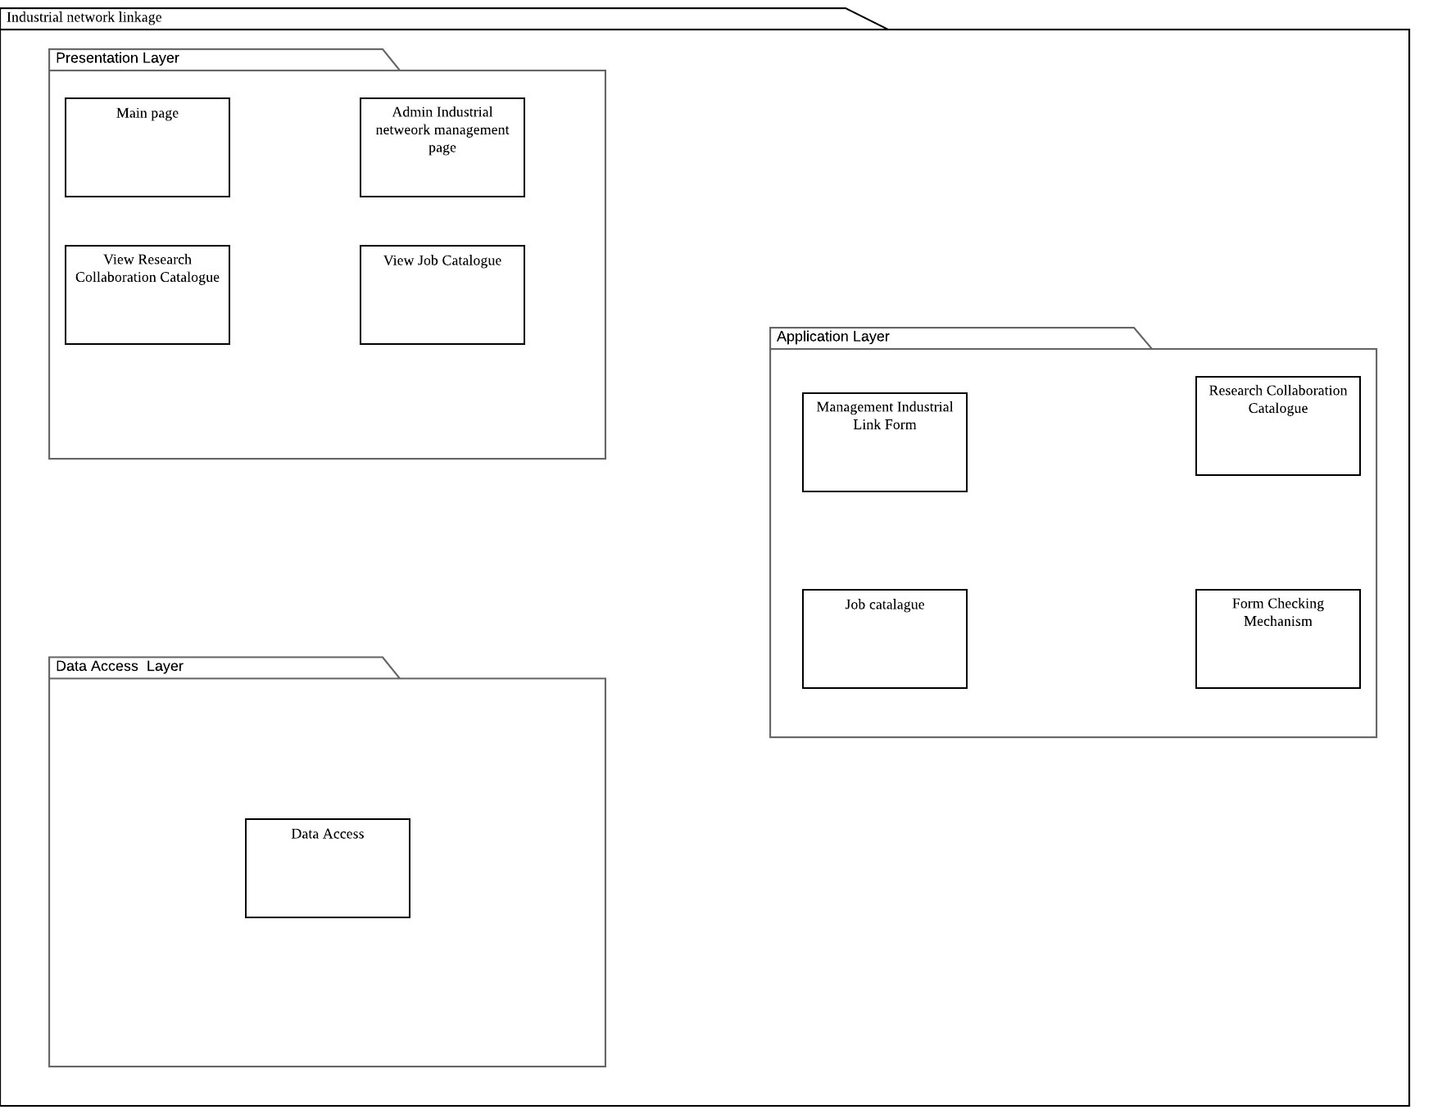**3.2.4.1 P007: Package Industrial Network Linkage**

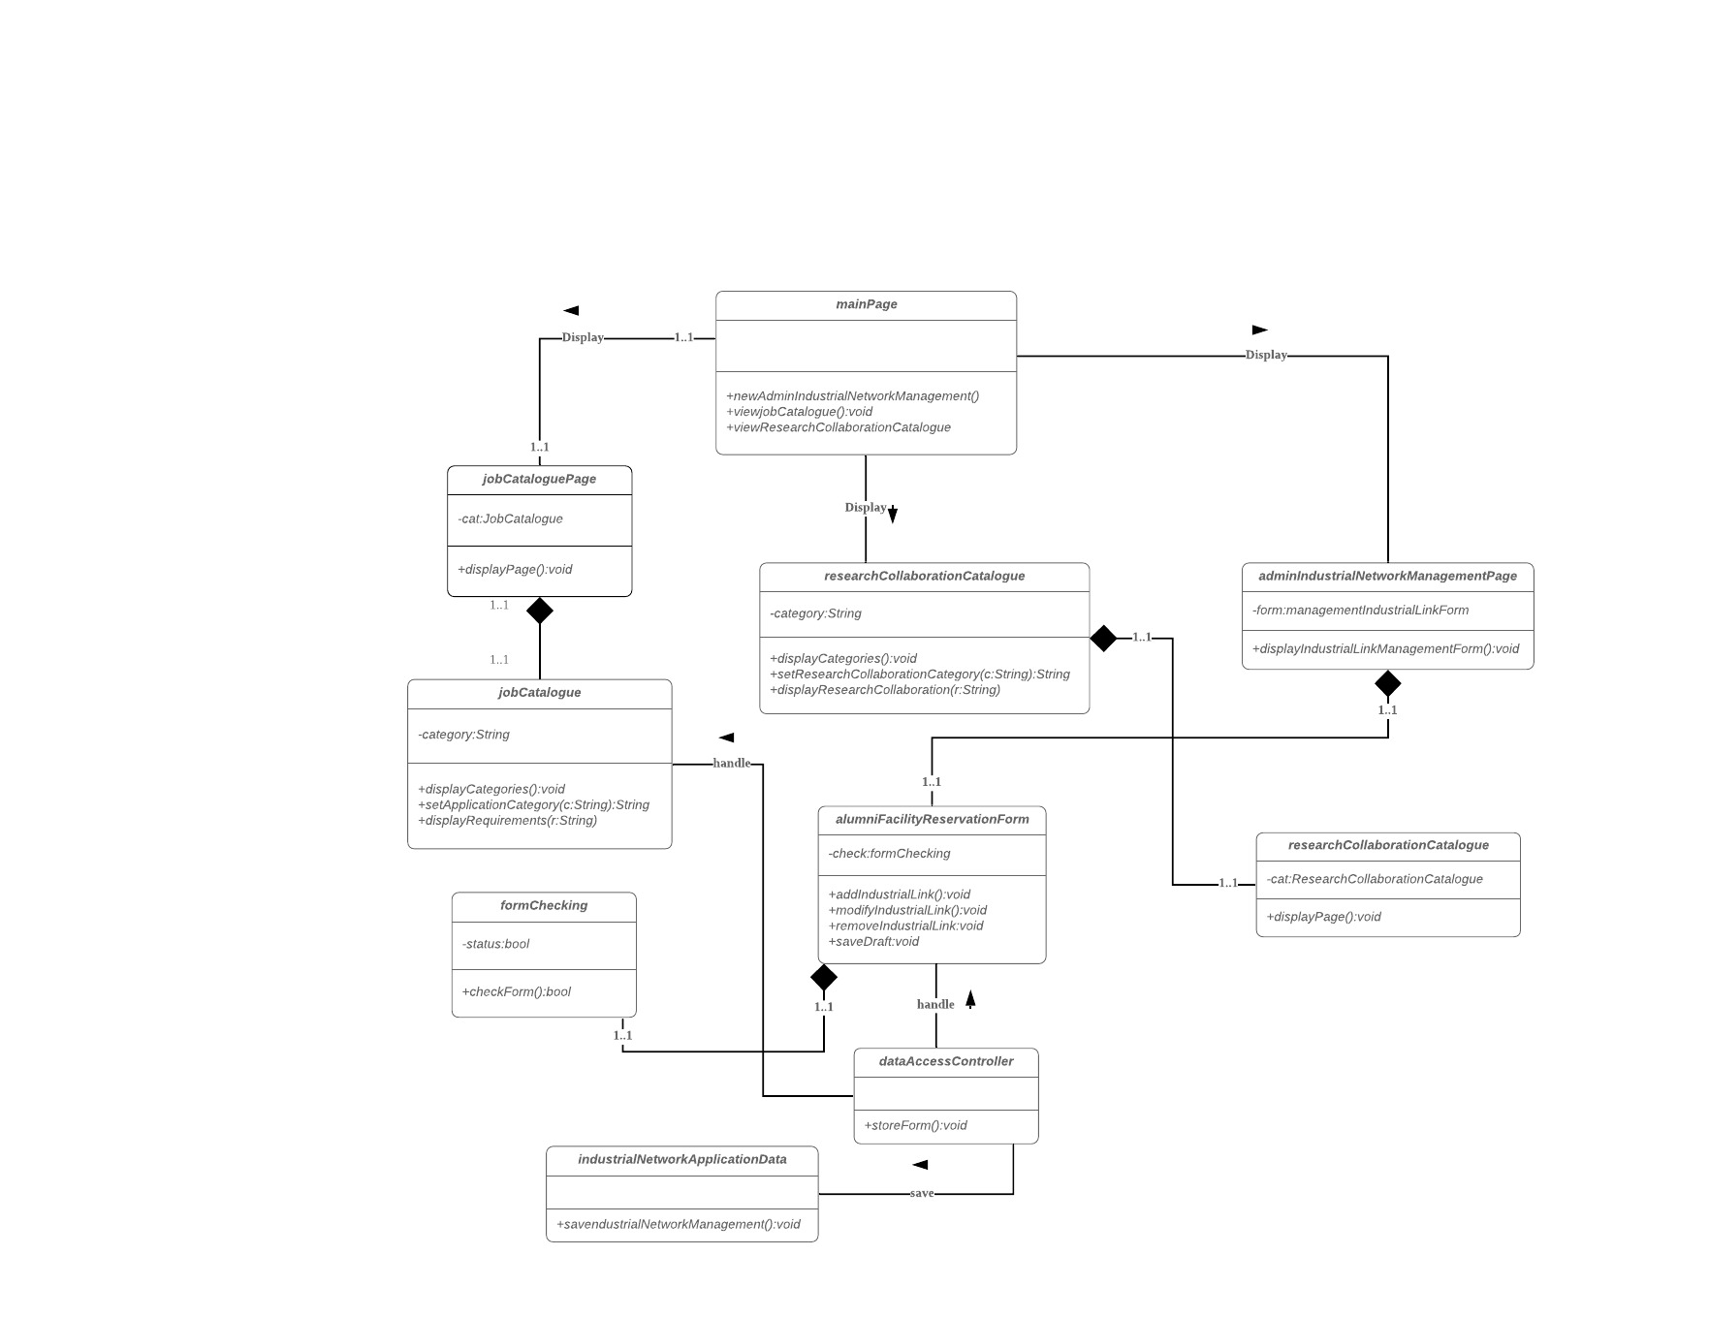**3.2.4.2** **Class Diagram**

**3.2.4.3** **Sequence Diagrams SD007: Industrial Network Linkage**

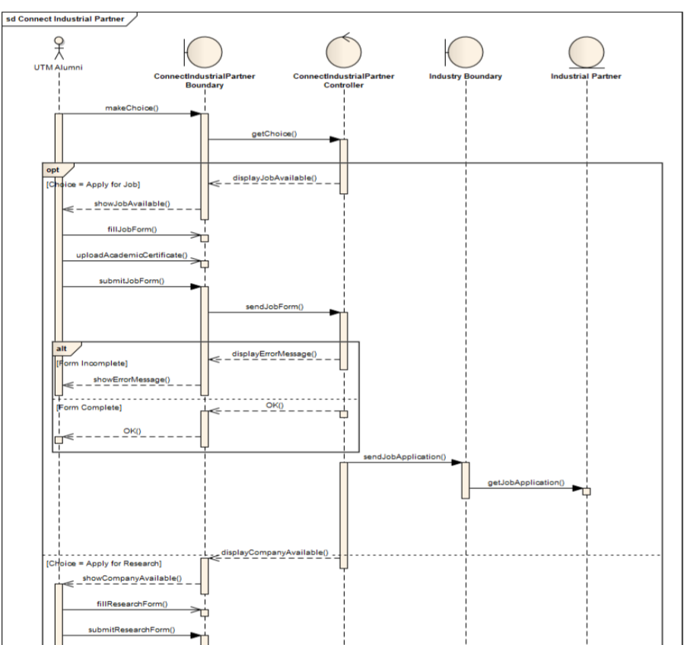

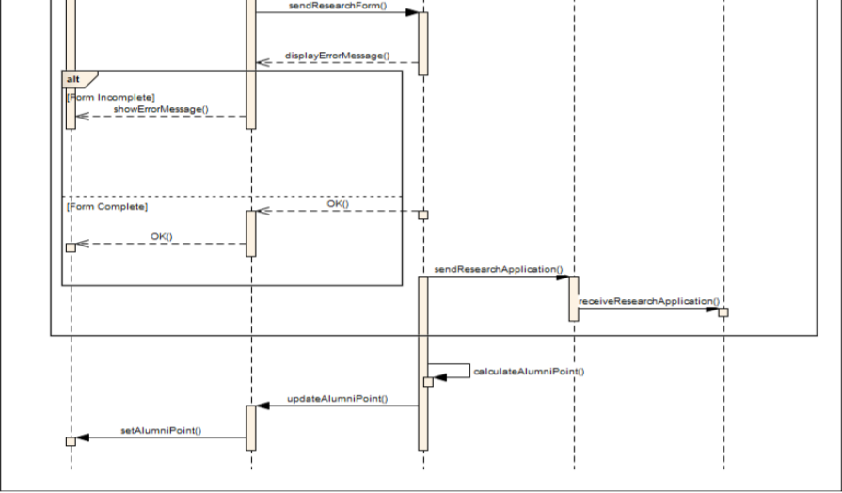

**3.2.5** **Module Report and Statistics**

**3.2.5.1** **P008: Package Report and Statistic Subsystem**

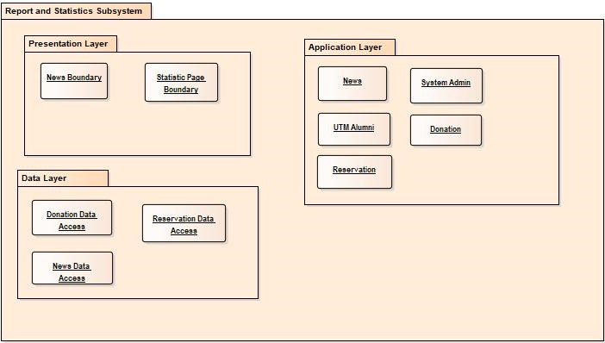

**3.2.5.2** **Class Diagram**

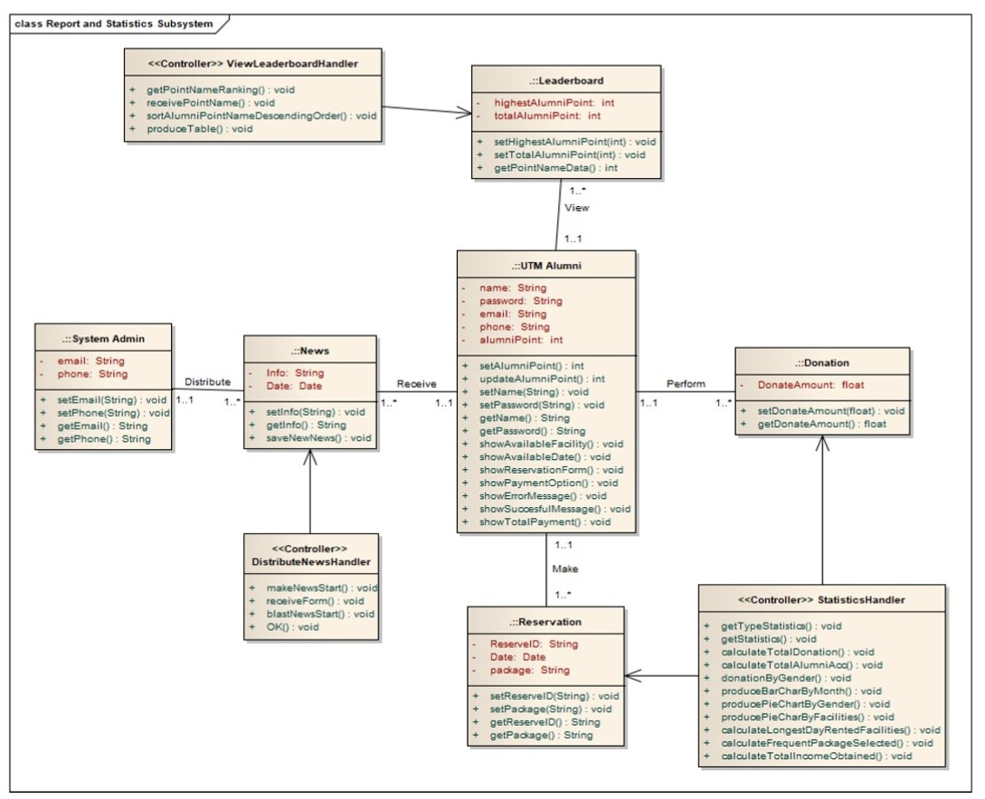

**Figure 3.2.5.2: Class diagram for Report and Statistic Subsystem**

**3.2.5.3.1** **Sequence Diagrams SD008: View Leader Board**

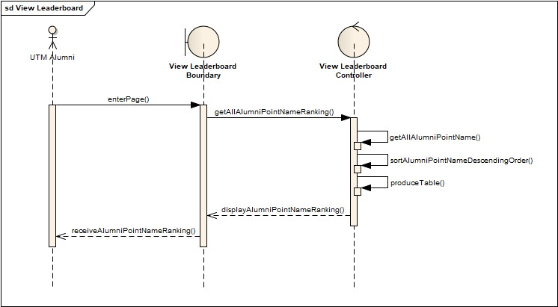

**Figure 3.2.5.3.1: Sequence Diagram of View Leaderboard**

**3.2.5.3.2** **Sequence Diagrams SD009: Distribute News**

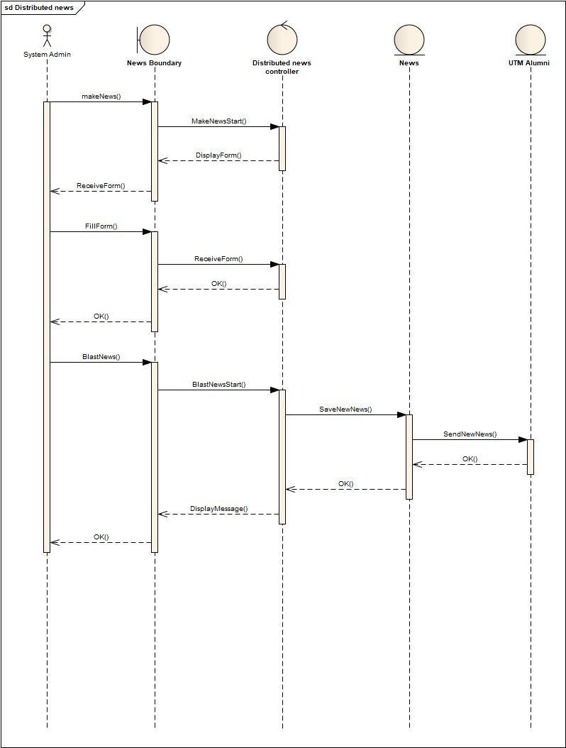

**Figure 3.2.5.3.2: Sequence Diagram of Distribute News**

**3.2.5.3.3** **Sequence Diagrams SD010: View Statistics**

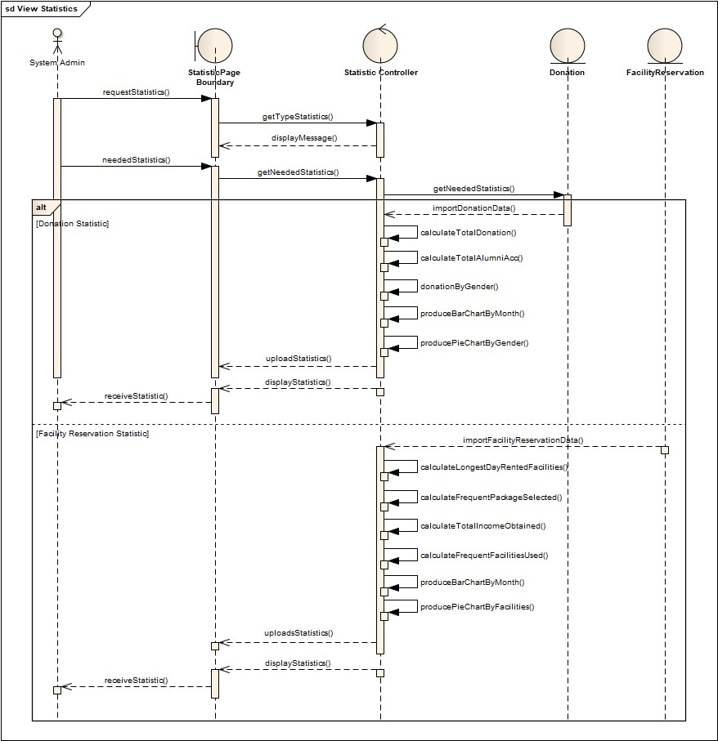

**Figure 3.2.5.3.3: Sequence Diagram of View Statistics**

**4.** **Data Design**

**4.1** **Data Description**

|  |  |
| --- | --- |
| **Entity Name** | **Description** |
| Admin | General terms defining system managers. |
| Alumni | General term describing all data of alumni |
| Registration | Registration process describing all data of alumni and employer. |
| Reservation | General term describing all data of alumni |
| Job | General term describing all data of Job |
| Employer | The person/company that provide jobs for the Alumni |
| Donation | General term describing all data of donations. |
| Organizations | General term describing all data of organizations that organize campaign. |

**4.2** **Data Dictionary**

4.2.1 Alumni

|  |  |  |
| --- | --- | --- |
| **Attribute Name** | **Type** | **Description** |
| alumniId | VARCHAR(10) | A primary key that uniquely identify each of the alumni. |
| name | VARCHAR(20) | Data that record the name of alumni |
| email | VARCHAR | Data used for thea alumni to receive notification and validation information. |
| phoneNo | VARCHAR | Data that used to contact the alumni |

4.2.2 Admin

|  |  |  |
| --- | --- | --- |
| **Attribute Name** | **Type** | **Description** |
| AdminId | VARCHAR(10) | A primary key that uniquely identify each of Admin |
| name | VARCHAR(20) | Data that record the name of alumni. |
| email | VARCHAR | Data used for thea alumni to receive notification and validation information. |
| Contact | VARCHAR | Data that used to contact. |

4.2.3 Registration

|  |  |  |
| --- | --- | --- |
| **Attribute Name** | **Type** | **Description** |
| RegistrationID | VARCHAR | A primary key to keep track of each user’s registration. |
| RegistrationDate | DATE | Data that record the date of registration. |
| AdminiId | VARCHAR(10) | A primary key that uniquely identify each of Admin and required to validate users. |
| alumniId | VARCHAR(10) | A primary key that uniquely identify each of the alumni and needed for validation during registration process |
| employerID | VARCHAR(10) | A primary key that uniquely identify each of the employer and needed for validation during registration process. |

4.2.4 Reservation

|  |  |  |
| --- | --- | --- |
| **Attribute Name** | **Type** | **Description** |
| reserveID | int | A primary key that uniquely identify each of the reservation. |
| Facilityid | VARCHAR(50) | The Id uniquely identified each facility reserved |
| Facilityname | VARCHAR(50) | The name of the facility reserved. |
| Startdate | DATE | The start date of the reservation. |
| Starttime | TIME (7) | The start time of the reservation. |
| Enddate | DATE | The end date of the reservation |
| Endtime | TIME (7) | The end time of the reservation |
| Totalprice | FLOAT (53) | The total price needed to be paid for the reservation. |
| Status | VARCHAR (50) | The status of the reservation made, got 3 options which are Pending, Approved or Denied |
| AdminID | VARCHAR (20) | A foreign key that uniquely identify which admin manage each of the reservation. |
| AlumniID | VARCHAR (20) | A foreign key that uniquely identify which alumni make each of the reservation. |

4.2.5 Job

|  |  |  |
| --- | --- | --- |
| **Attribute Name** | **Type** | **Description** |
| jobID | VARCHAR(10) | A primary key that uniquely identify each of the job. |
| jobName | VARCHAR(20) | The name of the job |
| jobQualification | VARCHAR | The requirement needed for the specific job |

4.2.6 Employer

|  |  |  |
| --- | --- | --- |
| **Attribute Name** | **Type** | **Description** |
| employerID | VARCHAR(10) | A primary key that uniquely identify each of the employer. |
| email | VARCHAR | Data used for the employer to receive notification and validation information. |
| jobProvided | VARCHAR | The job provided from the Employer to the Alumni |

4.2.7 Donation

|  |  |  |
| --- | --- | --- |
| **Attribute Name** | **Type** | **Description** |
| donateId | VARCHAR(10) | A primary key that uniquely identify the donations made. |
| date | DATE | Data that record the date of donations made |
| notes | TEXT | Data that record any notes by the alumni for the donations made |

4.2.8 Organizations

|  |  |  |
| --- | --- | --- |
| **Attribute Name** | **Type** | **Description** |
| orgId | VARCHAR(10) | A primary key to identify the organizations / owner of the campaign. |
| orgname | VARCHAR(20) | Data that record the organizations name. |

**5.** **User Interface Design**

**5.1** **Overview of User Interface**

**5.1.1 Manage Membership**

This module has 3 functionalities. Register for alumni, login into the website and only admin can extract data from the databases that are connected. First the Alumni has to register giving all the personal details that are needed in the form given by the page. Then after registration the alumni can sign in to the website through the login page. They need to put the correct credentials or else the website will provide a dialogue box saying Wrong Username or Password. The admin can also sign in the same way. The 3rd functionality is extract data which can be done only by the admin. The admin goes to the extraction page then selects the database from where to extract the data and also provides the Name and the IC number of the alumni whose data the admin wants to extract. After the website extracts the data the admin can modify the data, delete the data and then export the data to the database.

**5.1.2 Activity Management**

User will be provided with options to choose whether they want to donate or register activity.

If the user clicks donate, user will be redirected to a webform in which it receives the donation money and does not ask for any personal identity. If the user chooses to register activity, user will be shown a list of activity where user can choose the activity they want to join and enter no of participant will be joining with the user. Personal information of the user will be taken from the session the user logged.

**5.1.4 Industrial Linkages**

There is an option given to the user with simple choices which is Research Collaboration and Job Catalogue. If the user chooses Research Collaboration then the user will be directed to the following page. In the following page the user has to choose the research category and apply. Then the user will be directed to fill up a form. Once done, a message will be displayed stating the application is complete and will be directed to the main page. If the user chooses Job Catalogue then the user will be directed to the following page. In the following page, the user has to choose a job that is suitable for them and apply. Then the user will be directed to the job information page where the user will be able to see the displayed details of the job applied. Upon confirming the details, the user will be directed to a form to fill up the user’s details. Once done, a message will be displayed stating the application is complete and will be directed to the main page.

**5.2** **Screen Images**

**5.2.1 Manage Membership Module**

**5.2.1.1 Registration Interface**

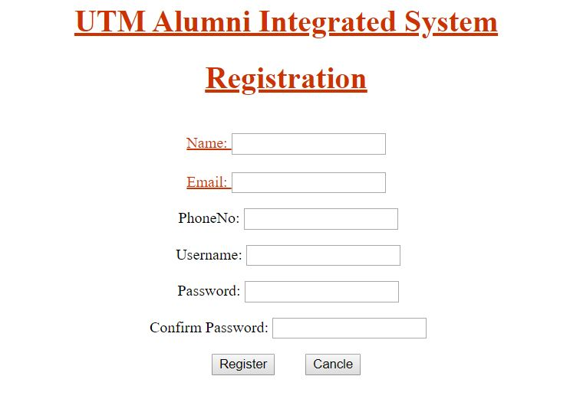

**Fig 5.2.1.1: Interface for Registration of alumni**

**5.2.1.2 Login Interface**

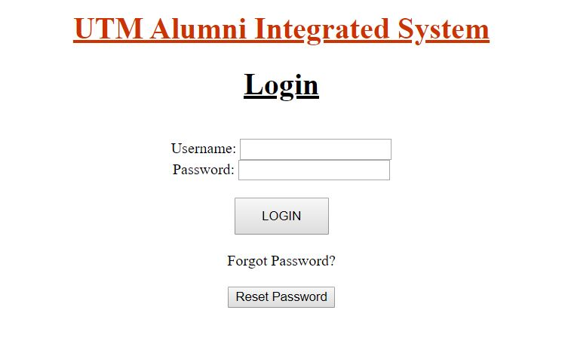

**Fig 5.2.1.2: Interface for Login of Alumni and System Admin**

**5.2.1.3 Data Extraction Interface**

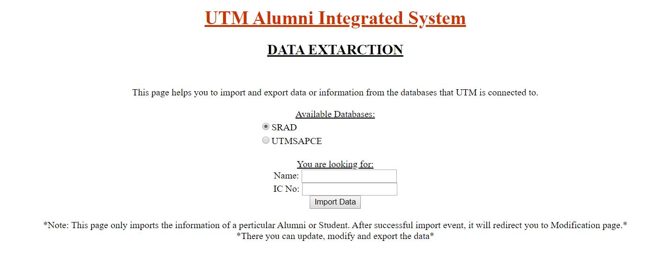

**Fig 5.2.1.3: Interface for Data extraction.**

**5.2.1.4 Data Modification Interface**



**Fig 5.2.1.4: Interface for Data modification for admin**

**5.2.2 Activity Management**

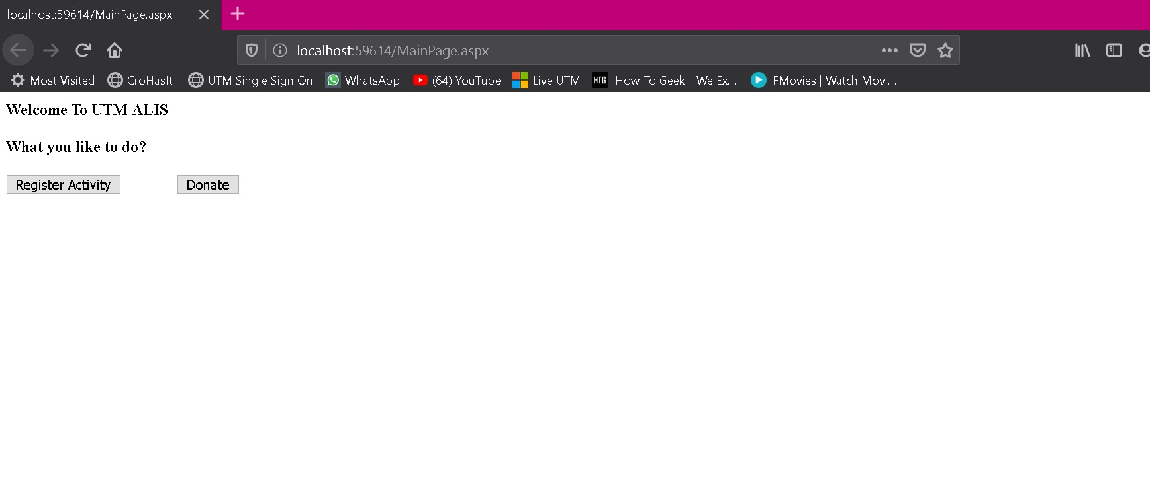

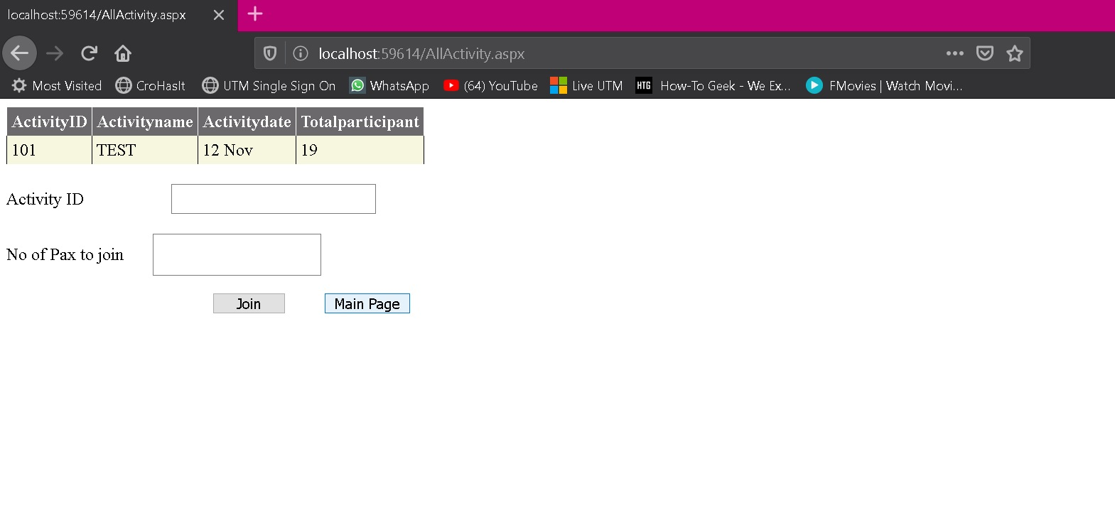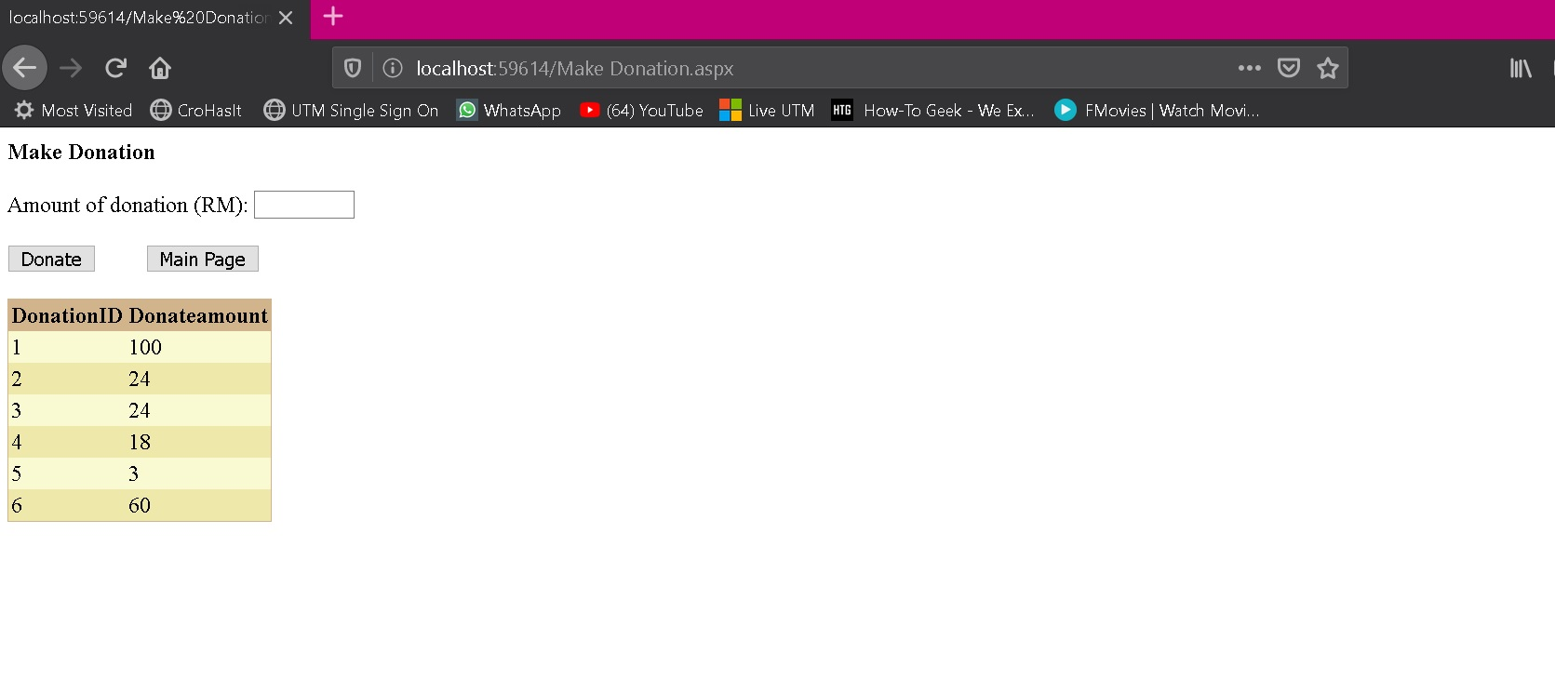

**5.2.3 Reservation facility :**

**5.2.3.1 : View Facility :**

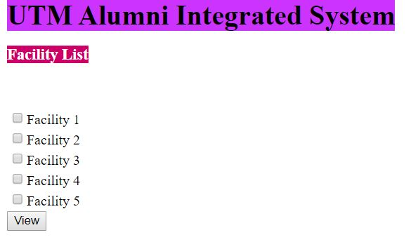

**5.2.3.2 : Facility Details**

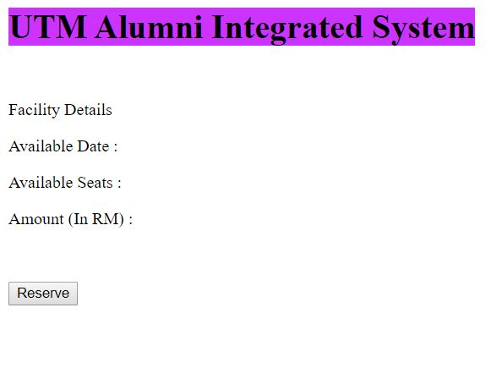

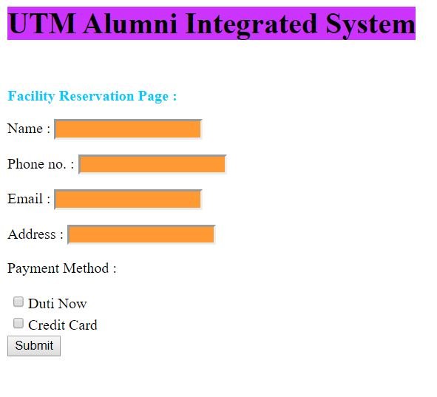**5.2.3.3 : Reservation**

**5.2.3.4 : Payment by DutiNow**

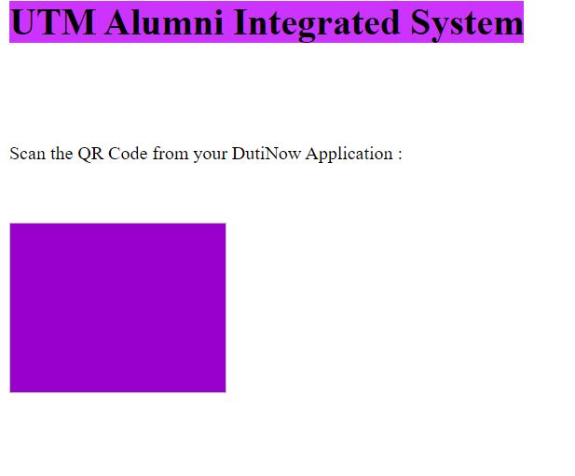

**5.2.3.5 : Payment by Credit Card**

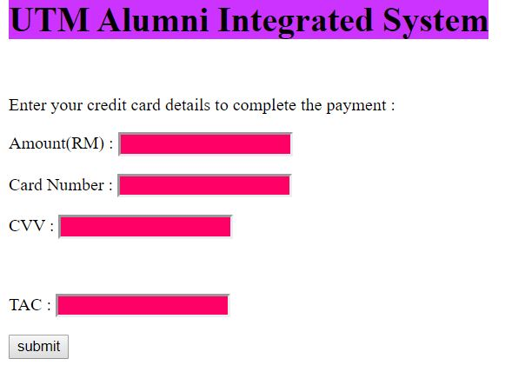

**5.2.4 Industry Linkage**

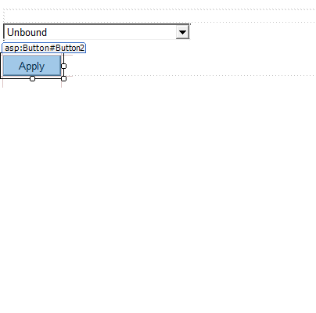**5.2.4.1 Main page** 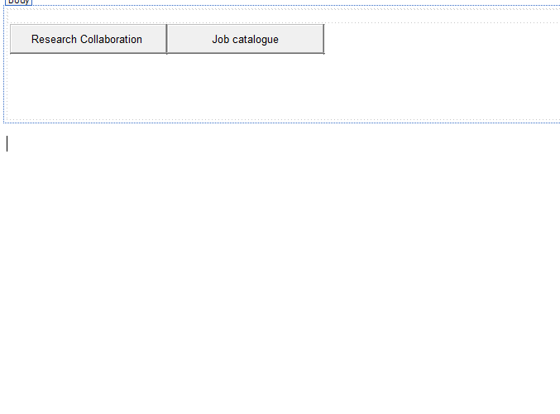

**5.2.4.2 Research Collaboration category**

**5.2.4.3 Form application**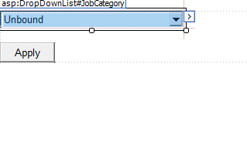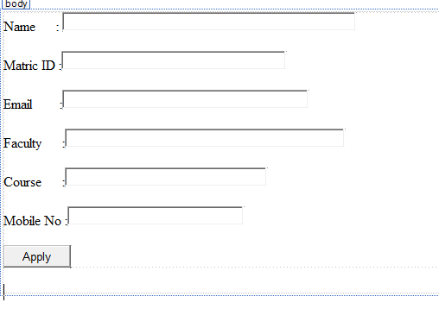

**5.2.4.4 Job Category**

**5.2.4.5 Job Information**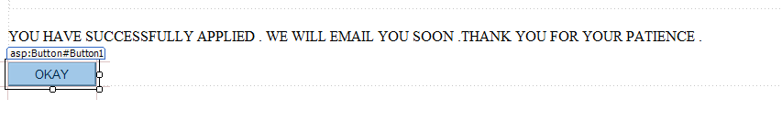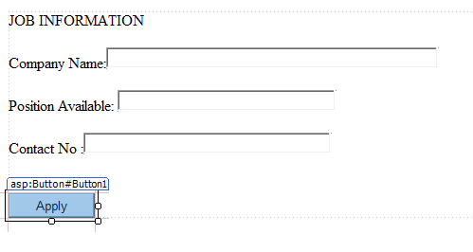

**5.2.4.6 Success Message**

**5.2.5 Report and Statistics**

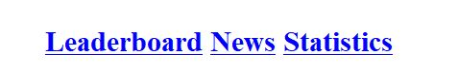

**5.2.5.1 Main page**

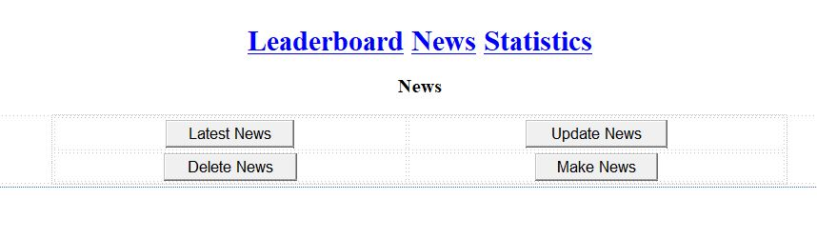

**5.2.5.2 News page (example if user click News from main page)**

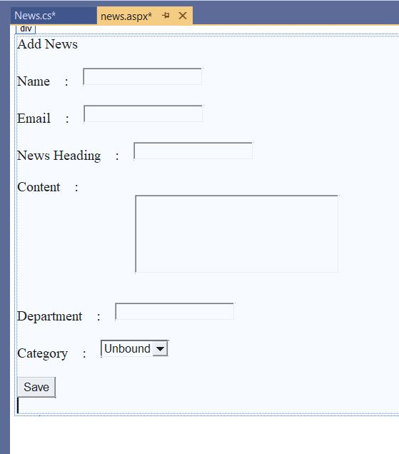

**5.2.5.3 Add News page**

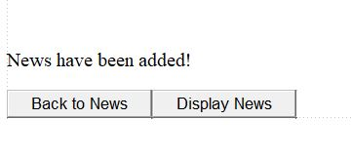

**5.2.5.4 News Information**

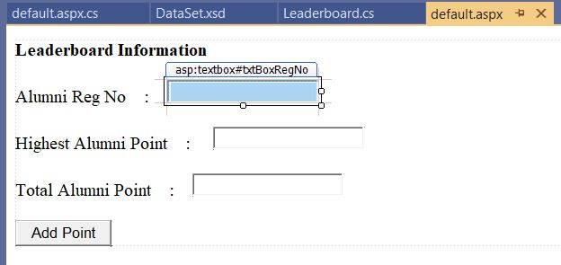

**5.2.5.5 Leaderboard page**

**6.** **Requirements Matrix**

|  |  |  |  |  |  |
| --- | --- | --- | --- | --- | --- |
|  | P001 | P002 | P003 | P004 | P005 |
| Module 1, UC001 | X |  |  |  |  |
| Module 1, UC002 | X |  |  |  |  |
| Module 1, UC003 | X |  |  |  |  |
| Module 1, UC004 | X |  |  |  |  |
| Module 2, UC005 |  | X |  |  |  |
| Module 2, UC006 |  | X |  |  |  |
| Module 3, UC007 |  |  | X |  |  |
| Module 3, UC008 |  |  | X |  |  |
| Module 3, UC009 |  |  | X |  |  |
| Module 4, UC010 |  |  |  | X |  |
| Module 4, UC011 |  |  |  | X |  |
| Module 4, UC012 |  |  |  | X |  |
| Module 5, UC013 |  |  |  |  | X |
| Module 5, UC014 |  |  |  |  | X |
| Module 5, UC015 |  |  |  |  | X |

**7.** **Design Pattern**

* Adapter Design Pattern

<class diagram>

<description of the adapter>

* A screenshot of a cell phone

  Description automatically generatedPrototype Design Pattern

The prototype is implemented in donation module . It clones the donation module which eases the donation process .

**8.** **Construction Design**

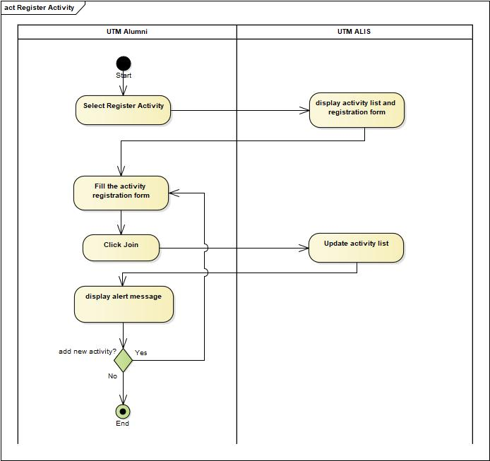8.1 Flow based

Figure 8.1.1 Register Activity Flow based

In this register activity module, UTM Alumni could view and register activity in UTM. First, go to activity page and select Register Activity. The system should display activity list and registration form should be available. Then, UTM Alumni needs to fill the activity registration form and click Join to submit. The system will update the activity list and display an alert message to show that the activity is successfully registered. If the alumni want to add more activity, they can directly fill the activity registration again and follow the steps as before, else the operation end.

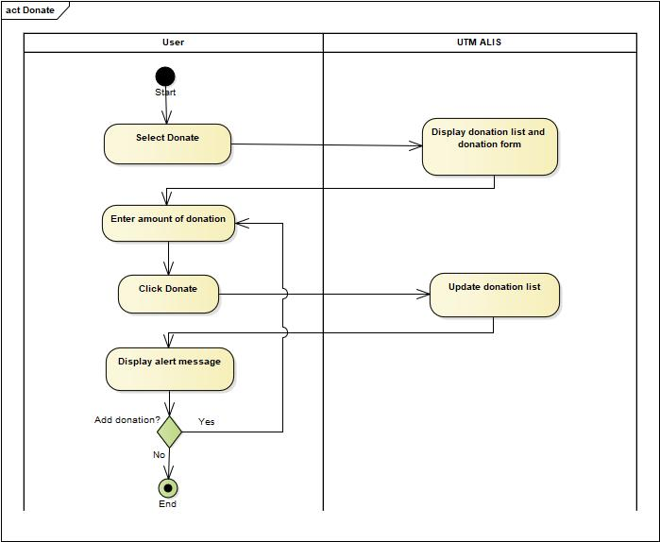

Figure 8.1.2 Donate Money Flow based

In this donation module, UTM Alumni could make a donation and view donation in UTM. First, go to activity page and select donate. The system should display donation list and donation form should be available. Then, UTM Alumni needs to enter the amount of donation and click Donate to submit. The system will update the donation list and display an alert message to show that the donation is successfully donated. If the alumni want to add more donation, they can directly enter the amount of donation again and follow the steps as before, else the operation end.

8.2 State based

8.3 Table based

|  |  |  |  |  |  |  |  |  |
| --- | --- | --- | --- | --- | --- | --- | --- | --- |
| Alumni Type | R | R | R | R | V | V | V | V |
| ActivityNum >10 | T | F | F | F | T | F | F | F |
| ActivityNum=1 | F | T | F | F | F | T | F | F |
| 1< ActivityNum=<10 | F | F | T | F | F | F | T | F |
| 10 points | X |  |  |  | X |  |  |  |
| 15 points |  | X |  |  |  | X |  |  |
| 5 points |  |  | X |  |  |  | X |  |
| 0 points |  |  |  | X |  |  |  | X |
| Add Free | FOOD&DRINK | DRINK | FOOD | - | FOOD&DRINK  AND EXTRA  10POINTS | FOOD&DRINK  AND EXTRA  15POINTS | FOOD&DRINK  AND EXTRA  5POINTS | - |

In the activity module , a membership concepr is being applied as where the alumni will be awarded creditscore for the participation . Each creditscore has something such as food and drinks to be awarded . The alumni is divided in two category such as regular and VIP .